Internship Report
AI-Assisted Automation Platform for Interface Control Document (ICD) Generation

Name: Kinthada Baladithya
Role: Engineer (Intern)
Internship Start Date: 15-12-2025
Internship End Date: 13-03-2026
Internship Manager:
Gaurav Rohilla
Digital SL
Cyient | Mobile: +91 9958900509
Office Location: Cyient Manikonda, Hyderabad, Telangana

Table of Contents

Introduction

Architecture Diagram

Tools and Technologies Used

Internship Responsibilities

Learning and Development

Challenges and Solutions

Conclusion

Introduction
During my internship at Cyient, I worked on designing and implementing an automated solution for generating production-ready Interface Control Documents (ICDs) used in large-scale enterprise systems. The main objective of the project was to reduce manual documentation effort while improving consistency, traceability, and compliance with enterprise system requirements.
The project involved developing an AI-Assisted ICD Automation Platform, which programmatically generates structured and styled ICD documents for Concession Instance APIs aligned with NZ-REQ-1265 to NZ-REQ-1278 requirements.
The platform automatically generates structured documentation including:
- API interface definitions
- Request and response schemas
- Error handling models
- Interface lifecycle flows
- Requirement-level sequence diagrams
- Verification and interface mapping details
The generated outputs follow a standard enterprise ICD format and are exported in both Word and PDF formats, ensuring consistent styling, section hierarchy, and formatting using a reference template. The system also integrates contextual information from System Architecture Documents (SAD), High-Level Design (HLD) artifacts, and API specifications to ensure the generated documentation bodies accurate, traceable, and aligned with enterprise standards.

Architecture Diagram
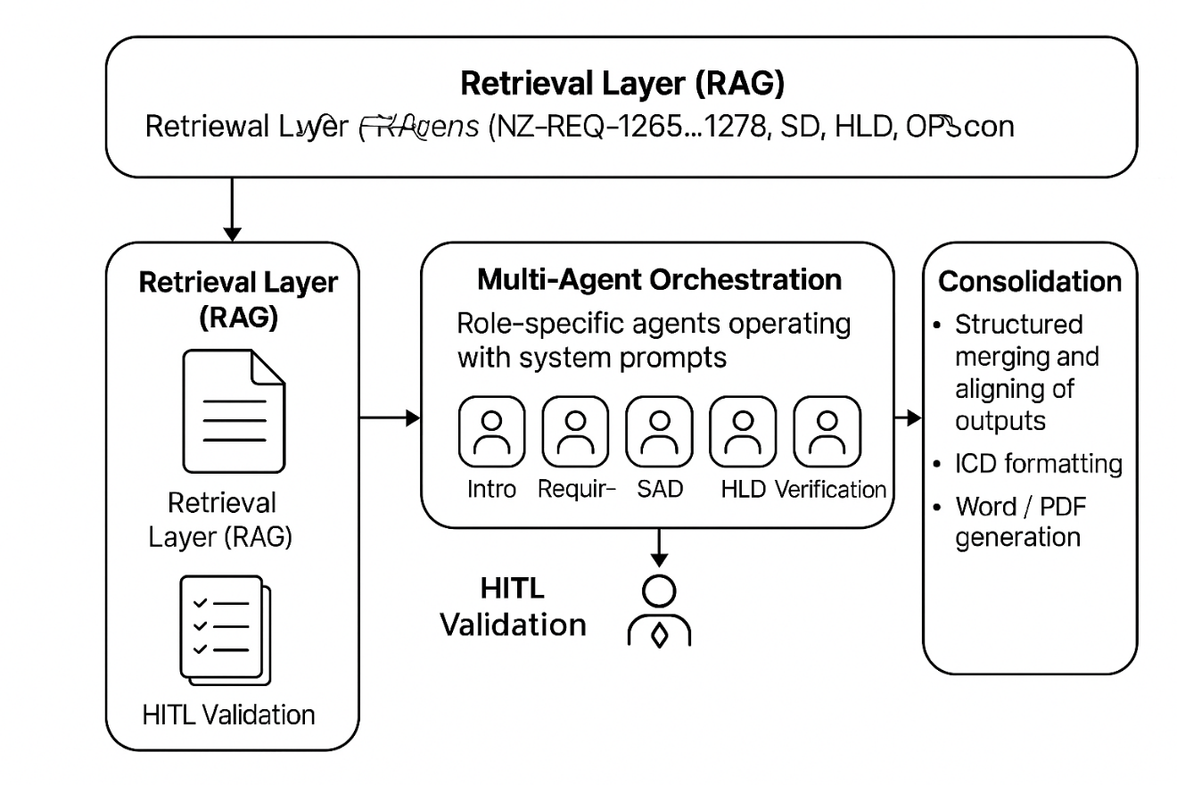
Figure : Architecture of the AI-Assisted ICD Automation Platform
The architecture of the system follows a Retrieval-Augmented Generation (RAG) based multi-agent pipeline designed to generate enterprise-grade Interface Control Documents.
The architecture consists of three primary layers:-
1. Retrieval Layer (RAG):
This layer retrieves contextual information from architecture and design artifacts such as SAD, HLD, API specifications, and requirement documents. Azure AI Search is used to perform vector and keyword-based retrieval, ensuring relevant context is supplied to the AI agents.
2. Multi-Agent Orchestration Layer:
This layer coordinates multiple AI agents responsible for generating different sections of the ICD. Each agent operates with system prompts and role-specific instructions to produce structured outputs such as introduction, requirement mapping, interface definitions, verification details, and traceability information. Human-in-the-loop validation is included to ensure correctness.
3. Consolidation and Document Generation Layer:
The consolidation agent merges the outputs generated by different agents, aligns them with the ICD template, and formats the document into structured sections. The final output is generated in Word and PDF formats, including embedded diagrams, schema tables, and interface definitions.
Validation mechanisms such as traceability checks, schema verification, and diagram validation are applied to ensure that the generated ICD aligns with enterprise documentation standards.

Tools and Technologies Used
The project utilized a combination of software engineering tools, AI technologies, and documentation frameworks to automate ICD generation.
Programming & Frameworks
- Python
- python-docx
- ReportLab
- Matplotlib
Artificial Intelligence Technologies
- Generative AI
- Agentic AI
- Azure OpenAI
- Retrieval-Augmented Generation (RAG)
Cloud & Search Technologies
- Azure AI Search
- Vector Search
- Embeddings-based document retrieval
Documentation & Visualization
- Microsoft Word (DOCX templates)
- PDF document generation
- Mermaid-style sequence diagrams
- Architecture and flow diagrams
Data & Integration Sources
- System Architecture Documents (SAD)
- High-Level Design Documents (HLD)
- API specifications
- Requirement datasets (NZ-REQ-1265 to NZ-REQ-1278)

Internship Responsibilities

Throughout the internship, I was responsible for both technical design and implementation tasks related to ICD automation.
My key responsibilities included:
• Analyzing NZ-REQ-1265 to NZ-REQ-1278 requirements and mapping them to API functionalities such as:
- Concession issuance
- Retrieval and update operations
- Suspension and resumption
- Revocation workflows
- Fare-media associations
- Bulk operations
- Audit tracking
• Designing and developing the AI-Assisted ICD Automation Platform capable of generating full enterprise ICD documentation automatically.
• Implementing functionality to read a reference DOCX template, extract section hierarchy, headings, styles, and formatting rules.
• Automating the generation of structured ICD sections including:
- Numbered headings
- API interface tables
- Request/response schema tables
- Consistent Table of Contents
• Integrating Azure AI Search to retrieve contextual information from architecture and design artifacts.
• Implementing Generative AI and Agentic AI components using Azure OpenAI to generate controlled technical documentation content.
• Designing prompt-scoped AI agents to ensure documentation generation remains restricted to the defined NZ-REQ scope.
• Defining standardized API documentation structures, including:
- Request payload schemas
- Response formats
- Header definitions
- Lifecycle attributes
• Implementing enterprise-grade error models covering standard HTTP response codes:
- 400 – Bad Request
- 401 – Unauthorized
- 403 – Forbidden
- 404 – Not Found
- 409 – Conflict
- 500 – Internal Server Error
• Demonstrating optimistic concurrency control using ETag and If-Match headers within API documentation examples.
• Generating requirement-level sequence diagrams programmatically and embedding them within the document.
• Ensuring final document quality through format validation, export checks, and layout consistency for both Word and PDF outputs.

Learning and Development

This internship significantly enhanced both my technical capabilities and professional engineering skills.
Major learnings include:
• Advanced usage of Python for enterprise automation systems, emphasizing modular and scalable design.
• Hands-on experience with python-docx for generating structured Word documents with styling, headings, and tables.
• Practical exposure to ReportLab for generating professional PDF documents.
• Understanding the structure and governance of enterprise API documentation.
• Experience with Azure AI Search for retrieving architecture and design context using both keyword and vector search.
• Exposure to Generative AI and Agentic AI systems used for controlled technical documentation generation.
• Designing AI prompt-scoped agents that ensure generated outputs remain within strict documentation boundaries.
• Learning best practices for API documentation standards, including:
- Semantic versioning
- Change management
- Requirements traceability
- Interface verification planning
• Improved understanding of system integration concepts, including interface contracts, lifecycle management, and data exchange.
• Strengthened analytical thinking, debugging, and technical decision-making skills in a real enterprise development environment.

Challenges and Solutions

Challenge 1: Handling Large and Unsupported Images in Word Documents
Problem: Some architecture and flow images were too large or incompatible with Word formatting standards.
Solution: Implemented an automated image re-encoding and downscaling utility that converts images to optimized formats and caps maximum dimensions while preserving readability.
Challenge 2: Requirement Gaps While Maintaining Strict Scope Control
Problem: Certain implementation details were missing in source artifacts, but the ICD still needed to remain complete.
Solution: Clearly labeled such elements as “Inferred from standard enterprise practices” and strictly constrained them to the Concession API domain to avoid scope leakage.
Challenge 3: Maintaining Visual Parity Between Word and PDF Outputs
Problem: Differences in layout engines caused inconsistencies in styles, margins, and colors.
Solution: Parsed the reference DOCX structure and explicitly applied the same hierarchy, spacing, and visual profile to both Word and PDF generation pipelines.
Challenge 4: Sequence Diagram Rendering Without External Dependencies
Problem: Standard diagram tools were not available in all environments.
Solution: Implemented a lightweight Mermaid-style sequence diagram renderer using Python and matplotlib as a fallback solution.

Conclusion

The internship project successfully delivered an AI-Assisted ICD Automation Platform capable of generating enterprise-grade Interface Control Documents with minimal manual intervention.
The platform significantly improves documentation efficiency while ensuring accuracy, traceability, and compliance with enterprise standards.
By integrating Generative AI, Agentic AI, and retrieval-based knowledge systems, the solution demonstrates how modern AI technologies can enhance enterprise documentation workflows.
This internship provided valuable exposure to real-world enterprise systems, AI-assisted engineering practices, and API governance frameworks.
Overall, my internship at Cyient was a highly enriching experience that strengthened my technical skills, problem-solving abilities, and understanding of enterprise software development practices.

